Gerstein Lab Experience with Predicting Allosteric Residues on the Protein Surface
We have extensive previous experience in predicting allosteric sites in proteins, with a focus on protein dynamics. We published and made available STRucturally-identified ESSential residues (STRESS), a software tool to predict allosteric pockets on the protein surface as well as allosteric residues within the interior (Clarke et al, 2016). To predict allosteric ligand binding sites on the surface, our approach identifies cavities whose occlusion would interfere with large-scale motions (see figure below). Candidate sites are modeled using anisotropic network models (ANMs) and alternative crystal structures to capture conformational changes. Sites are scored by how much their motions affect protein conformational changes, with high-scoring residues defining surface allosteric sites. We validated this method on known drug-binding sites.
Using models of protein conformational change, we have developed the comprehensive mathematical framework that incorporates protein structure and dynamics for predicting allosteric residues both on the surface and in the interior (stress.molmovdb.org). Computational efficiency has been a priority in the development of this framework, thereby enabling high- throughput analysis for large protein datasets, as well as elucidating properties that are general to allosteric residues.

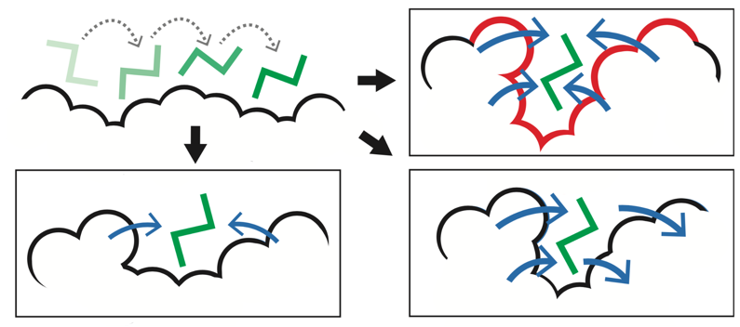
STRESS. Identifying key surface pockets using Monte Carlo simulations. This approach is designed to identify candidate sites wherein ligand occlusion may drastically affect conformational changes and dynamics (top-right).

Given that knowledge of protein dynamics is so integral to this framework, we have developed a pipeline for identifying alternative conformations of proteins throughout the PDB. The identification of likely allosteric residues within this set of dynamic proteins allows us to examine the biophysical and evolutionary features of the identified allosteric hotspots in a straightforward fashion. We have utilized this framework to generate and distribute a tool that enables users to submit their own structures for analysis. Several of the unique features include the fact that it is easy-to-use, computationally tractable, and capable of simultaneously identifying residues both at the surface and within the protein interior. The framework captures hotspot regions at the protein surface, but residues in the interior may also play allosteric roles. These interior residues often act by functioning as essential ‘bottlenecks’ in the communication pathways between distal regions. Therefore, we use principles from network theory, in conjunction with our models of conformational change, to predict allosteric residues within the interior.
Using the same dynamic model generation scheme applied by STRESS, we also developed ​​HotCommics, a framework to identify cancer driver genes using a dynamics-based search of mutational hotspot communities within structures (Kumar et al, 2019). Relative to existing cancer hotspot detection methods using structural data, we applied ​​HotCommics to demonstrate how protein dynamics significantly increases the sensitivity for detecting disease-associated gene.

Gerstein Lab Experience with Predicting Protein-Ligand Binding Affinities Using a Meta-Modeling based Framework
We have developed a sequence-based deep learning (DL) framework to predict binding affinity, and to thus rank different compounds based on their predicted binding affinities (Lee at al., 2024).
The accurate screening of candidate drug ligands against target proteins through computational approaches is of prime interest to drug development efforts. Such virtual screening depends in part on methods to predict the binding affinity between ligands and proteins. Many computational models for binding affinity prediction have been developed, but with varying results across targets.
Given that ensembling or meta-modeling approaches have shown great promise in reducing model-specific biases, we developed a framework to integrate published force-field-based empirical docking and sequence-based deep learning models. In building this framework, we evaluate many combinations of individual base models, training databases, and several meta-modeling approaches. We show that many of our meta-models significantly improve affinity predictions over base models. Our best meta-models achieve comparable performance to state-of-the-art deep learning tools exclusively based on 3D structures while allowing for improved database scalability and flexibility through the explicit inclusion of features such as physicochemical properties or molecular descriptors. We further demonstrate improved generalization capability by our models using a large-scale benchmark of affinity prediction as well as a virtual screening application benchmark. We demonstrate that diverse modeling approaches can be ensembled together to gain meaningful improvement in binding affinity prediction.

References

Clarke, Declan, Anurag Sethi, Shantao Li, Sushant Kumar, Richard WF Chang, Jieming Chen, and Mark Gerstein. "Identifying allosteric hotspots with dynamics: application to inter-and intra-species conservation." Structure 24, no. 5 (2016): 826-837.

Kumar, Sushant, Declan Clarke, and Mark B. Gerstein. "Leveraging protein dynamics to identify cancer mutational hotspots using 3D structures." Proceedings of the National Academy of Sciences 116, no. 38 (2019): 18962-18970.

Lee, Ho-Joon, Prashant S. Emani, and Mark B. Gerstein. "Improved prediction of Ligand–Protein binding affinities by Meta-modeling." Journal of Chemical Information and Modeling 64, no. 23 (2024): 8684-8704.

Mitternacht, Simon, and Igor N. Berezovsky. "Binding leverage as a molecular basis for allosteric regulation." PLoS computational biology 7.9 (2011): e1002148.

