Gerstein lab experience in studying QTLs
The Gerstein lab has extensive experience in eQTL analysis. Dr. Gerstein’s team is part of the PsychENCODE Consortium which has generated a comprehensive online resource for the adult brain across 1,866 individuals. This resource contains ~79,000 brain-active enhancers, sets of Hi-C linkages, and topologically associating domains; single-cell expression profiles for many cell types; eQTLs; and further QTLs associated with chromatin, splicing, and cell-type proportions (so-called cell fraction QTLs, or fQTLs) (Wang et al, 2018).

We have extensive experience in analyzing single-cell data for inferring cell-type-specific eQTLs. In a paper under revision, we integrated single-nucleus, multi-omics datasets from the PsychENCODE consortium to create a uniformly processed resource comprising >2.8M nuclei from the prefrontal cortex across 388 individuals. Across 17 distinct cell types, we identified >1.4M single-cell eQTLs (termed “scQTLs”), with an average of >85K cis-eQTLs per cell type and ~690 eGenes per cell type (see Fig. 1). Our scQTLs are strongly enriched in narrow regions around the transcription start sites, and many of them are cell-type-specific (though ~47% of them appear in more than one cell type). To perform our scQTLs search, we followed the same general procedure used by GTEx, including conservative filtering on the cell-type level when generating pseudobulk data. We used this set of scQTLs as our "core callset" for downstream analyses. Furthermore, ~30% of the scQTLs overlap with bulk cis-eQTLs

Gerstein lab experience in using LLMs to predict disordered proteins and misfolding
Protein phase transitions (PPTs), especially those observed as a result of disordered states and aggregation, have the potential to interfere with protein-ligand binding by altering target structures, reduce functional availability, and affect binding thermodynamics and kinetics. In our recent work, we leveraged LLMs by fine-tuning the pre-trained ESM-2 model to predict PPTs and aggregation (Frank et al, 2024). Specifically, we demonstrated that the LLM embedding vectors can differentiate between sequences with high aggregation propensity from those with low aggregation propensity.

Gerstein lab experience in using GNNs to predict Intrinsically Disordered Regions (IDRs)
We also developed a method that is designed to determine whether a specific subregion within a protein adopts disordered states (even if the entire protein itself does not adopt a disordered state) (Wang et al, 2024). Specifically, we introduced the GP-GNN framework, a GNN-based approach designed for predictive tasks where initially unknown subsystems may be crucial for information extraction. Our framework dynamically learns advantageous graph structures, hence, enabling improved graph representation learning. Specifically, we formulated a similarity measure that captures the probability of node pairs jointly exhibiting characteristic patterns within larger systems and used this measure to group nodes into clusters. Connections between clusters are considered unlikely to be relevant to the task and are removed, generating multiple subgraphs before graph representation learning via message passing. This is to confine information sharing within subgraphs during the initial network layers. We leveraged a linear layer to extract meta-features, allowing the similarity measure to be trained with task labels, thereby facilitating task-specific adjustments in the model’s predictions. In the final network layers, the framework captures interactions between the subgraphs. We demonstrated the effectiveness of GP-GNN for predicting protein liquid-liquid phase separation (LLPS), where the input consists of molecular protein graphs, and the output indicates whether the protein undergoes LLPS. Since LLPS is primarily driven by domains such as IDRs, GP-GNN identifies these critical domains as subgraphs. Our model achieved state-of-the-art performance in predicting LLPS proteins, including regulators and scaffolds, using both PDB and AlphaFold-generated graph structures. Additionally, in related work, we showed that a similar approach accurately identified tumor and microenvironment regions that align closely with pathologist annotations. (Song et al, 2024).

Gerstein lab experience in using protein dynamics to rank protein-ligand pairs
We developed STRESS, a tool to identify allosteric residues from protein structures (Clarke et al, 2016). STRESS employs coarse-grained models of protein dynamics and conformational changes in order to predict surface pockets that may strongly influence dynamics if occluded by ligands (Fig. 2). We have used this tool to highlight examples of allosteric residues that help explain disease-associated variants. Using the same dynamic model generation scheme applied by STRESS, we also developed ​​HotCommics, a framework to identify cancer driver genes using a dynamics-based search of mutational hotspot communities within structures (Kumar et al, 2019). Relative to existing cancer hotspot detection methods using structural data, we applied ​​HotCommics to demonstrate how protein dynamics significantly increases the sensitivity of cancer driver detection.

Gerstein lab experience in using population-level sequence data to quantify evolutionary conservation
We developed multiple computational tools and analysis pipelines to study genomic sequence variation and the associated downstream effects of variants. VAT (Variant annotation tool) annotates protein sequence changes resulting from genetic mutations, categorizing mutations as synonymous, missense, nonsense, or splice-site disrupting (Habegger et al, 2012). We also developed ALoFT (Annotation of Loss-of-Function Transcripts) predicts the disease-causing potential of loss-of-function (LoF) events, distinguishing between deleterious heterozygous and homozygous mutations, and it has been used to analyze somatic variants in cancer exomes (Balasubramanian et al, 2017). We applied the concept of localized protein frustration to evaluate the structural impact of variants by calculating changes in localized physical metrics to assess how genetic variants affect protein structure and stability (Kumar et al, 2016). This has been used to differentiate gain- and loss-of-function variants in oncogenes and tumor suppressors.
We also have extensive experience with conducting analyses related to allele-specific expression (ASE). In particular, we developed AlleleSeq, a computational pipeline that was originally used for identifying and quantifying ASE in GM12878 (Rozowsky et al, 2011). We have applied AlleleSeq to a broad spectrum of personal and functional genomics data. We annotated variants associated with ASE in a large pool of individuals from the 1000 Genomes Project. The results were made available as an online resource, AlleleDB (http://alleledb.gersteinlab.org) (Chen et al, 2016).

Gerstein lab experience in constructing regulatory networks in neurogenomic contexts
In our previous work (Emani et al, 2024), we developed an intercellular communication network by integrating publicly accessible ligand-receptor pair data with snRNA-seq. We identified distinct broad communication patterns among excitatory, inhibitory, and glial cell types, with significant alterations in these patterns observed in patients with neuropsychiatric disorders such as schizophrenia and bipolar disorder. Specifically, we noted that excitatory neurons showed reduced incoming signaling in schizophrenia, whereas inhibitory neurons exhibited increased signaling.

Figures
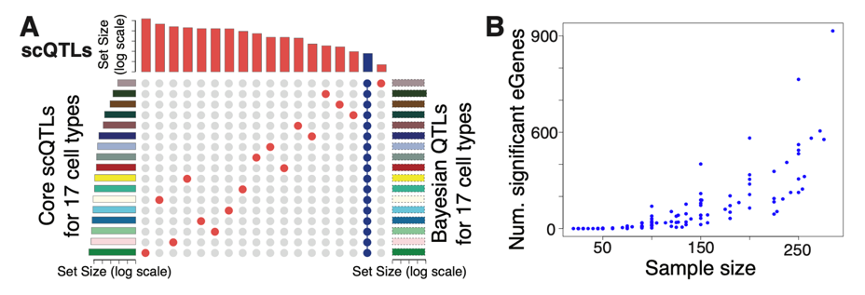
Figure 1. (A) UpSet plot with identified scQTLs (from the core analysis) that are unique to individual cell types (red) or across all cell types (blue). Left histogram summarizes the number of core scQTLs per cell type. Right histogram summarizes the log-scaled total number of Bayesian scQTLs per cell type. (B) Results from empirical power analysis in QTL calculations based on randomly sub-sampling data from the PsychENCODE dataset. Adapted from Emani et al, 2024.

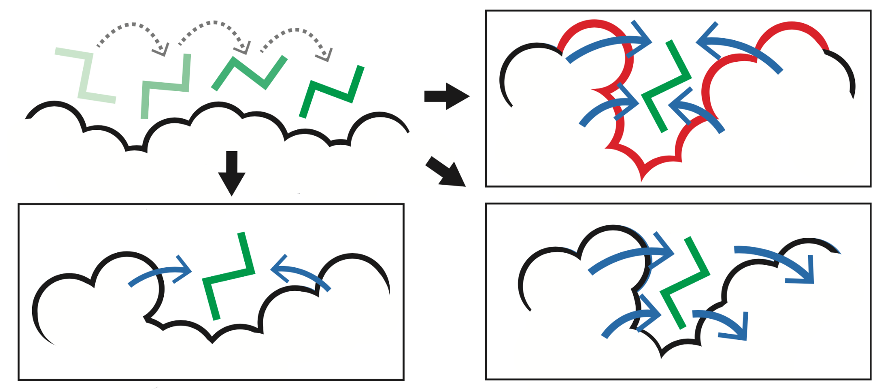
Figure 2. STRESS. Identifying key surface pockets using Monte Carlo simulations. This approach is designed to identify candidate sites wherein ligand occlusion may drastically affect conformational changes and dynamics (top-right).

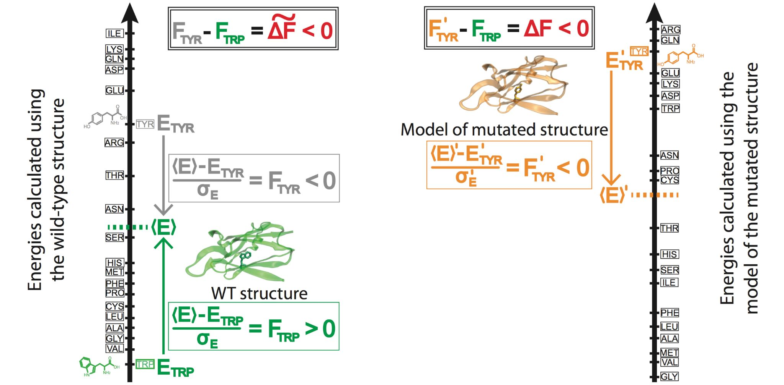
Figure 3. Prioritizing the effect of SNVs based on changes in localized perturbations (as measured by frustration).

VI. References

Balasubramanian, S. et al. Using ALoFT to determine the impact of putative loss-of-function variants in protein-coding genes. Nature communications 8, 382, doi:10.1038/s41467-017-00443-5 (2017).

Chen, J. et al. A uniform survey of allele-specific binding and expression over 1000-Genomes-Project individuals. Nature communications 7, 11101, doi:10.1038/ncomms11101 (2016).

Clarke, D., et al., Identifying Allosteric Hotspots with Dynamics: Application to Inter- and Intra- species Conservation. Structure, 2016. 24(5): p. 826-837.

Emani, P.S., et al., Single-cell genomics and regulatory networks for 388 human brains. Science, 2024. 384(6698): p. eadi5199.

Frank, M., Ni, P., Jensen, M. & Gerstein, M. B. Leveraging a large language model to predict protein phase transition: A physical, multiscale, and interpretable approach. Proceedings of the National Academy of Sciences of the United States of America 121, e2320510121, doi:10.1073/pnas.2320510121 (2024).

Habegger, L. et al. VAT: a computational framework to functionally annotate variants in personal genomes within a cloud-computing environment. Bioinformatics 28, 2267-2269, doi:10.1093/bioinformatics/bts368 (2012).

Kumar, S., Clarke, D., & Gerstein, M. (2013). Localized structural frustration for evaluating the impact of sequence variants. Nucleic acids research, 44(21), gkw927.

Kumar, S., D. Clarke, and M.B. Gerstein, Leveraging protein dynamics to identify cancer mutational hotspots using 3D structures. Proc Natl Acad Sci U S A, 2019. 116(38): p. 18962- 18970.
Rozowsky, J. et al. AlleleSeq: analysis of allele-specific expression and binding in a network framework. Molecular systems biology 7, 522, doi:10.1038/msb.2011.54 (2011).

Wang, Daifeng, et al. "Comprehensive functional genomic resource and integrative model for the human brain." Science 362.6420 (2018): eaat8464.

Wang, G., Warrell, J., Zheng, S. & Gerstein, M. A variational graph-partitioning approach to modeling protein liquid-liquid phase separation. Cell Reports Physical Science 5, doi:10.1016/j.xcrp.2024.102292 (2024).

